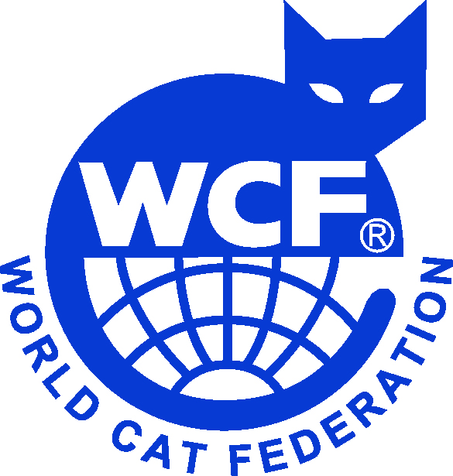 | 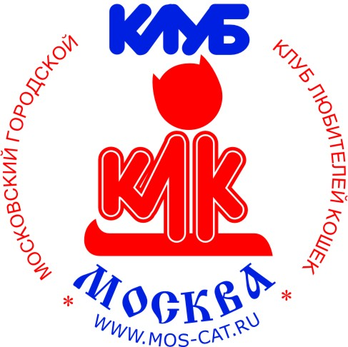  World Cat Federation (WCF)  ACF «M-Club», RU-0179  Клуб любителей кошек «МОСКВА»  (Клуб основан в 1987 году)
Grand Champion of Europe
Гpанд-Чемпион Евpопы
Title certificate
№ ________

Name:
Breed, color: | MCO n 22
Sex: | female
Date of birth:
Reg. number:
Owner:

The certificate was issued by results of following exhibitions:

Title | Judge | Date, place of show, license
CAGCE, Nom Bis | Makarova L.A. | 25.12.2021, Moscow, L#211060
CAGCE
CAGCE

President of ACF «M-Club»,
RU-0179 _____________________________ Makarova L.A.

Date:

